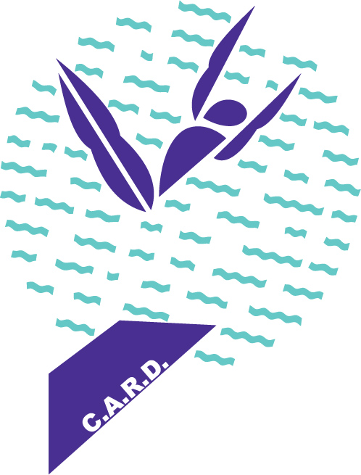

**K2 D I V I N G**

**(K SQUARED)**

**VIRGINIA BEACH, VA.**

**K2 DIVING Progression System**

|  |  |
| --- | --- |
| L E S S O N P R O G R A M | |
| *Basic and Intermediate Jumps and Line-Ups and Basic Dives* | |
| 1 meter | 3 meter |
| Front H-jump straight (no arm swing) | Front H-jump straight (no arm swing) |
| Front T-Y-O jump straight | Front T-Y-O jump straight |
| Front H-jump tuck (no arm swing) | Front H-jump tuck (no arm swing) |
| Front T-Y-O jump tuck | Front T-Y-O jump tuck |
| Front line-up pike grabbed (FLUG) | Front line-up ‘T’-position grabbed (FLUT) |
| Back H-jump straight (no arm swing) | Back H-jump straight (no arm swing) |
| Back T-Y-O jump straight | Back T-Y-O jump straight |
| Back H-jump tuck (no arm swing) | Back H-jump tuck (no arm swing) |
| Back T-Y-O jump tuck | Back T-Y-O jump tuck |
| Front “Hollow” dive | Front “Hollow” dive |
| Standing front dive tuck (no arm swing) | Front tuck roll off |
| Back line-up straight grabbed | Back line-up straight grabbed (*optional*) |
| Hopping front H-jump straight | Hopping front H-jump straight |
| Hopping circle (with arm swing) jump straight | Hopping circle (with arm swing) jump straight |
| Karate Kid with H-jump (no arm swing) | Karate Kid with H-jump (no arm swing) |
| Karate Kid circle (w/arm swing) jump | Karate Kid circle (w/arm swing) jump |
| 2-step hurdle – 100A | 2-step hurdle – 100A |
| 4-step hurdle - 100A | 4-step hurdle - 100A |
| *The front and back jumps are the most important skills in the sport of Diving. If you do not learn to jump correctly, you will not be able to learn more difficult dives in the future. The best divers in the world practice their jumps everyday. And you will too!* | |