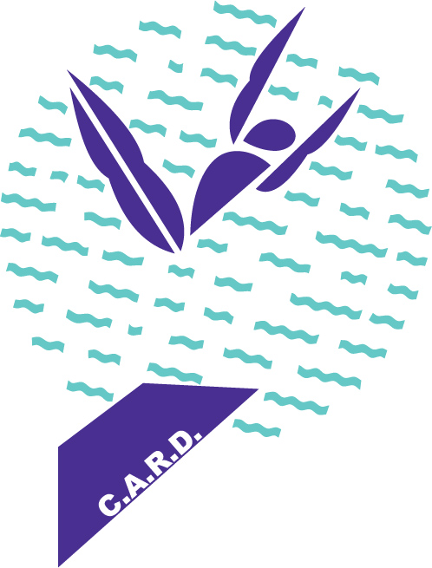

**K2 D I V I N G**

**(K SQUARED)**

**VIRGINIA BEACH, VA.**

**K2 DIVING Progression System**

|  |  |
| --- | --- |
| B R O N Z E T E A M | |
| *Intermediate Dives plus Basic and Intermediate Somersaulting* | |
| 1 meter | 3 meter |
| Standing 101 hollow | Back line-up tuck from squat |
| Standing 101 open pike grabbed | 101C |
| Sitting back line-up tuck from mat | 401C |
| 101C | 201C |
| 401C | 301C |
| 201C | 302C |
| 301C | 202C |
| 102C | 103C |
| 402C | 103B |
| 202C | 403C |
| 302C |  |
| 102B (open pike with arms in “T”) |  |
| 103C |  |
| 202A |  |

*If the dive is listed with the number only, this means that you should perform it with a full 3 or 4-step approach*

*or a complete back press (T-Y-O).*