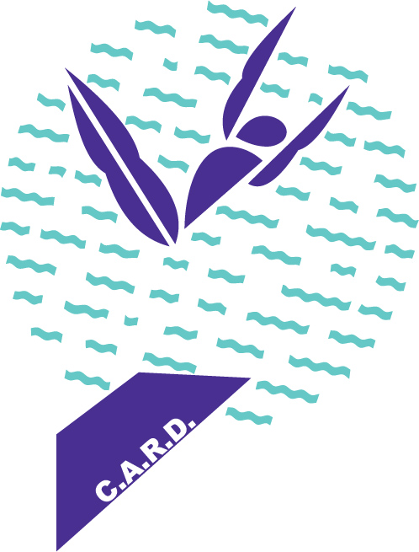

**K2 D I V I N G**

**(K SQUARED)**

**VIRGINIA BEACH, VA.**

**K2 DIVING Progression System**

|  |  |
| --- | --- |
| S I L V E R T E A M | |
| *Advanced Dives plus Basic Twisting* | |
| 1 meter | 3 meter |
| 101B | 101B |
| 201B | 201B |
| 301B | 301B |
| 401B | 401B |
| 104C |  |
| 5122D | 5132D |
| 5221D | 5231D |

*At times divers will learn skills out of order. Many divers will learn 5122 (front somersault full twist) before they learn a 301B (reverse dive pike). It’s OK. You might also complete the first 2 levels on 1 meter before you have any 3 meter certificates. That’s OK! We will keep encouraging and challenging you to improve your 3 meter skills. It’s really up to you to decide when you’re ready!*