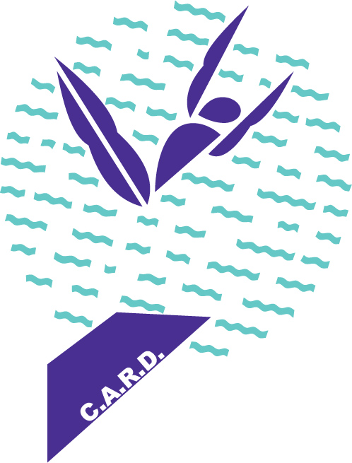

**K2 D I V I N G**

**(K SQUARED)**

**VIRGINIA BEACH, VA.**

**K2 DIVING Progression System**

|  |  |
| --- | --- |
| G O L D T E A M E L I T E | |
| *Complex Somersaulting and Complex Twisting* | |
| 1 meter | 3 meter |
| 105B/C | 105B |
| 403B | 405C |
| 203B | 205C |
| 204C | 305C |
| 303B | 5134D |
| 304C | 5233D |
| 5134D | 5235D |
| 5233D | 5333D |
| 5225D |  |
| 5331D |  |
| 5333D |  |
| 5126D* *not mandatory, but encouraged* | 5136D* *not mandatory, but encouraged* |