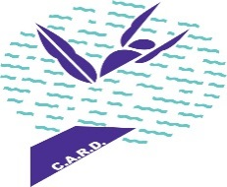

**K2 D I V I N G**

**(K SQUARED)**

**VIRGINIA BEACH, VA.**

**MEDICAL TREATMENT PERMISSION & ACKNOWLEDGEMENT OF RISK:**

In consideration of my participation in the activity provided by and through the K2 Diving Club, I, for myself or on behalf of the participant who I represent, authorize K2 Diving Club employees to take and provide all necessary medical attention should I, or the participant who I represent, be injured while participating or being transported to or from any K2 Diving Club-sponsored activity. I have read the policies pertaining to cancellations, rules and regulations as they pertain to this activity. I acknowledge the risks and responsibilities involved in these activities, and assume the risks and responsibilities involved in these activities. I assume these risks realizing the capabilities of the person(s) participating. I have read this release and understand all its terms and execute it voluntarily and with full knowledge of its significance

Signature of participant / parent or guardian Date

Name of Diver / participant